

**TFB1033**

**OBJECT ORIENTED PROGRAMMING**

**MAY 2024**

**PARCEL HUB SYSTEM**

**LECTURER:**

**DR NORDIN ZAKARIA**

|  |  |  |  |
| --- | --- | --- | --- |
| **No** | **GROUP MEMBERS** | **STUDENT ID** | **COURSE** |
| 1. | MUHAMMAD AMIER IRFAN BIN MUHAMMAD ALI JR | 22006313 | INFORMATION TECHNOLOGY |
| 2. | FARHAN BIN IZAM FAIRUS | 22006657 | INFORMATION TECHNOLOGY |
| 3. | MUHAMMAD ASHRAF BIN HARRIS | 22001716 | INFORMATION TECHNOLOGY |
| 4. | BAT’RISYIA DIYANAH BINTI FADIL SANUSI | 22011685 | INFORMATION TECHNOLOGY |
| 5. | MIRZA IMRAN BIN BAHARIN | 22005917 | COMPUTER ENGINEERING |

**Video Link:** [**https://drive.google.com/file/d/1TwsnEUvZz-gBrf2w-ETfo_8ixu-iH8l3/view?usp=drive_link**](https://drive.google.com/file/d/1TwsnEUvZz-gBrf2w-ETfo_8ixu-iH8l3/view?usp=drive_link)

Table of content

Project Overview 3

Project GUI 5-17

UML Diagram 19

**Project** **Overview**

The Parcel Hub System is designed to simplify the process of tracking and retrieving parcels for users at the University Technology Petronas parcel hub. The system’s objectives are to reduce waiting times, increase efficiency and offer additional services such as payment processing and point collection for promotions.

**Objectives:**

* Allow user to track their parcels easily.
* Shorten waiting times at the parcel hub.
* Enable users to make payments via the system.
* Allow users to collect points for future promotions.
* Help parcel hub stuff manage parcels more effectively by giving real-time updates on parcel availability.
* Decrease the quantity of unclaimed parcels.

**Expected results:**

* User can enter their tracking number and parcel size to receive real-time updates.
* Shorter lineups at the parcel hub.
* Improved time efficiency for both users and staff.
* Improved management of parcels by staff, knowing when parcels are prepared for pick-up.
* Reduction in unclaimed parcels.

**Project Justification:**

* Current parcel hub systems are slow, causing long wait times.
* Limited storage space for the influx of daily parcels due to unclaimed items.
* The new system aims to address these issues by offering a more efficient and user-friendly solution.

**Originality:**

* The Parcel Hub Systems is an original project specifically tailored for the University Technology Petronas parcel hub.

**Special Features:**

* Focuses on solving the specific problems faced by the university parcel hub staff.
* Contains login and signup pages for staff, students and guests.
* Streamlines the process for staff by allowing them to scan student’s matric cards for payments.
* Automatically returns parcels to the seller if not collected within the pickup time, reducing overcrowding.
* Provides staff with tools to monitor profits, successful and failed parcel deliveries and user statistic.

The Parcel Hub System is designed to enhance the efficiency and user experience at the University Technology Petronas parcel hub. By addressing the current challenges and implementing innovative features, the project seeks a smoother workflow for staff and improve user satisfaction.

**PROJECT GUI**

1. Login interface

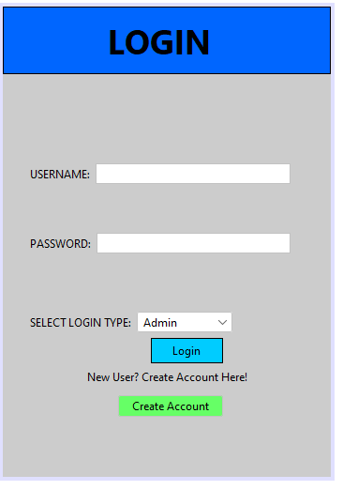

Explanation:

The login interface allows users (students and staff) to access the system. Users must provide their login information to authenticate and gain access to their respective functionalities within the system.

2. Sign Up interface

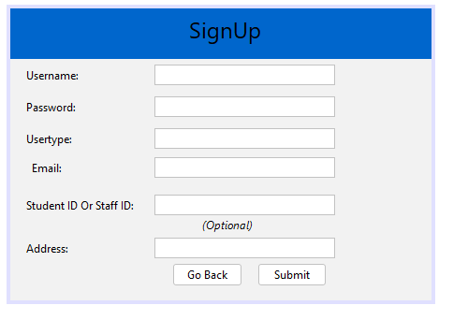

Explanation:

The sign-up interface is designed for new users to create an account. Users register in the system by entering the required information, which includes their name, email address, password, and user type (staff or student).

3. User Homepage (Usertype: User)

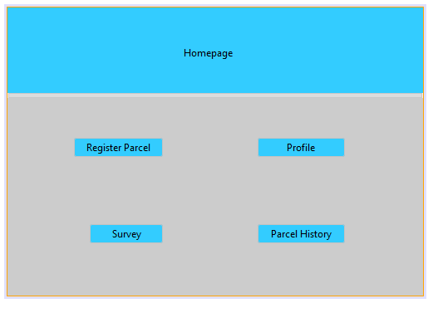

Explanation:

The user homepage serves as the main dashboard for logged-in users. It provides an overview of the user's account, along with parcel tracking status, notifications, and quick access to other features including payment and parcel registration.

4. User Parcel History (Usertype: User)

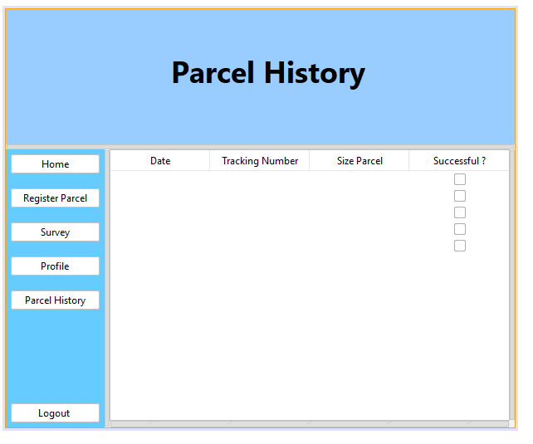

Explanation:

The parcel history interface displays a list of parcels associated with the user. It includes information such as tracking number, parcel size, status updates, and delivery history, enabling users to keep track of their parcels.

5. User Register Parcel (Usertype: User)

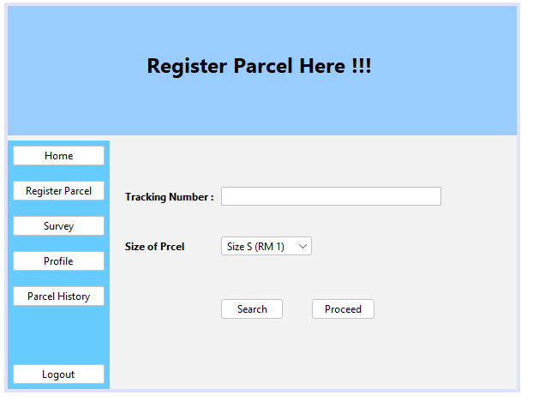

Explanation:

The user register parcel interface is for user to track their parcel. The user register parcel interface displays a tracking number for user to fill in, the size of their parcel, search button and proceed button to track user’s parcel.

6. User Payment (Usertype: User)

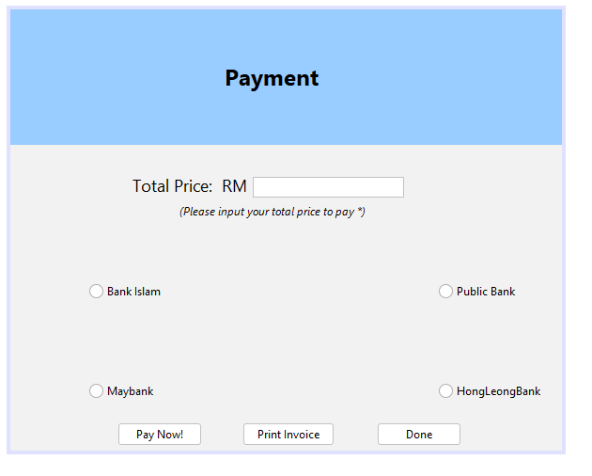

Explanation:

The user payment interface is for the user to fill in the exact total price to pay for the service. The user payment interface displays total price for user to fill in, types of banks to choose, pay now button for user to pay immediately, print invoice button for the payment receipt and done button.

7. User Review (Usertype: User)

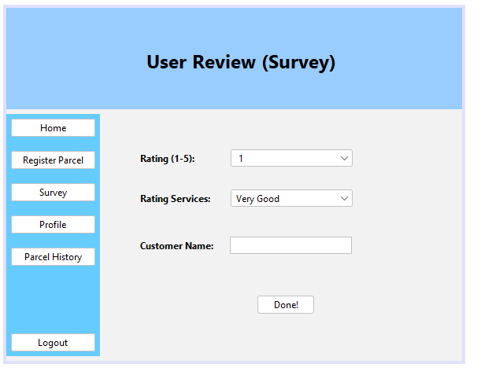

Explanation:

The user review interface is for user to enter their feedback for the service. The user review interface displays rating, rating services and customer name for customer to fill in theirs.

8. User Profile (Usertype : User)

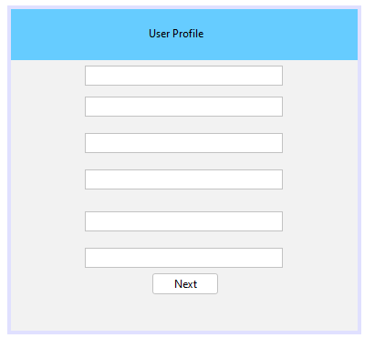

Explanation:

The user profile interface will show profile and details of user after they registered. The user profile will display username, password, usertype, email, student id and address.

9. Admin Homepage (Usertype: Admin)

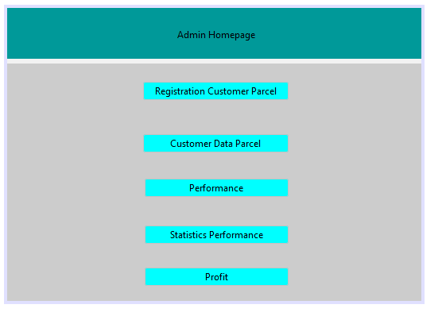

Explanation:

The admin homepage interface is for admin view the data for the service. The admin homepage interface displays registration customer parcel, customer data parcel, performance, statistics performance, and profit.

10. Admin Parcel Registration (Usertype: Admin)

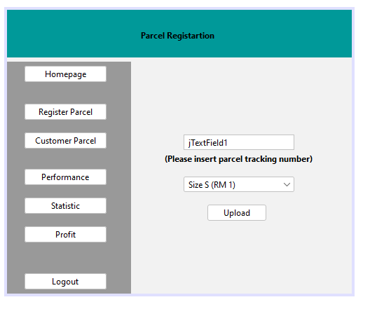

Explanation:

The admin parcel registration interface is for admin to register parcel into the system. The admin parcel registration interface displays text field to fill the tracking number, size option for the parcel and upload button.

11. Admin Profit (Usertype: Admin)

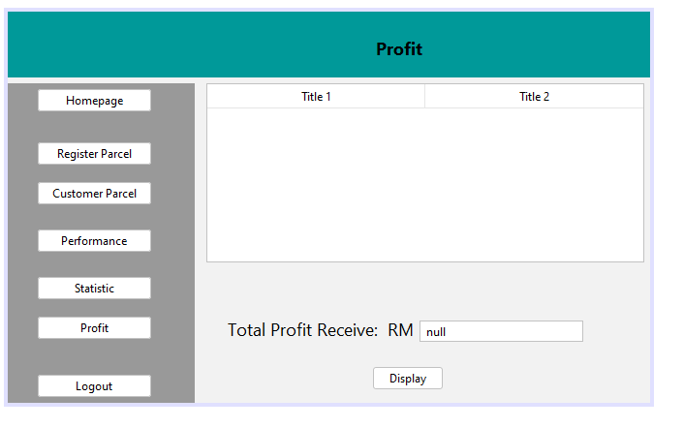

Explanation:

The admin profit interface is for the admin to know the profit they get. The admin profit interface shows list of the parcel registered, total profit receives in ringgit Malaysia and display button.

12. Admin Performance (Usertype: Admin)

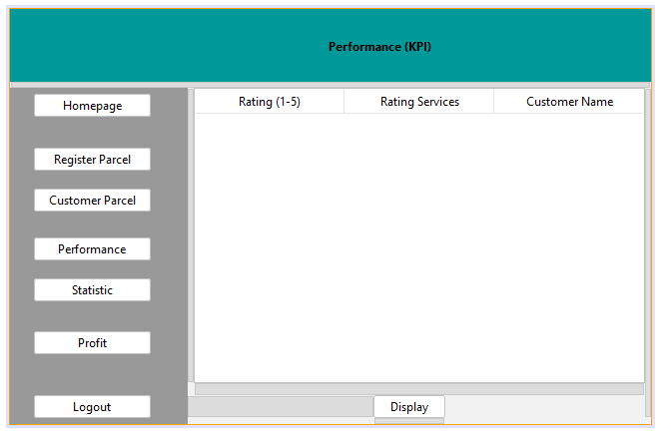

Explanation:

The admin performance interface is for admin to know the feedback they receive from user. The admin performance interface displays rating, rating services, customer name and display button.

13. AdminCustomerParcel (Usertype:Admin)

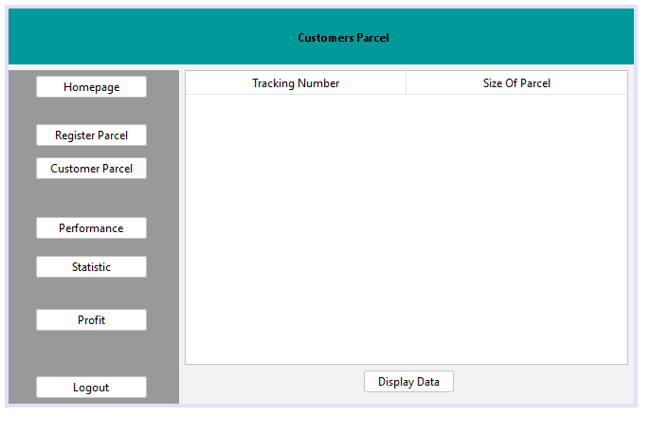

Explanation:

The display button data will collect all the tracking number and the size of parcel from the adminParcelRegistration database and will be displayed in the table above.

14. Admin Profile: (Usertype : Admin)

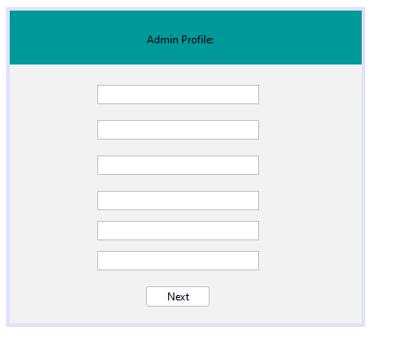

Explanation:

The admin profile interface will show profile and details of admin after they registered. The admin profile will display username, password, usertype, email, student id or staff id and address.

**UML Diagram**

